REVA UNIVERSITY
School of Computer Science and Engineering

MLOps — Internal Examination Report

Project Title:
LOCAL KNOWLEDGE CHATBOT

Student Name(s) | [Thanuja], [Seema], [Geethika], [Varshini]
SRN(s) | [R23EA081], [R23EA111], [R23EA069], [R23EA068]
Semester / Year | [6th Semester, 2025-26]
Section | [Section B]
Guide / Faculty | [R Swasthik, Designation]
Course | Machine Learning Operations (MLOps)
Submission Date | [10/04/2026]

Abstract
MLOps (Machine Learning Operations) bridges the gap between machine learning model development and production deployment. This report presents a project-based exploration of the MLOps lifecycle, including problem formulation, dataset selection, model selection (LLM or otherwise), pipeline design, and deployment strategy.

This project presents the development of a local knowledge chatbot model designed to provide accurate, context-aware information specific to a defined region or domain. The primary problem addressed is the lack of reliable, localized information in general-purpose chatbots, which often provide generic or irrelevant responses. This limitation is significant because users frequently seek precise, location-specific knowledge such as local services, academic resources, or community information.
To solve this, we built a chatbot powered by a Large Language Model (LLM) integrated with a curated local dataset. The dataset includes region-specific documents, FAQs, and structured knowledge sources collected from trusted local platforms. We used a transformer-based LLM (such as GPT-based or open-source alternatives like LLaMA) and enhanced it with retrieval-augmented generation (RAG) to ensure accurate and up-to-date responses. The system was developed using a complete Machine Learning Pipeline, including data collection, preprocessing, embedding generation, model integration, and evaluation.
An MLOps framework was implemented to streamline model training, versioning, monitoring, and deployment. Tools such as containerization and cloud/local deployment environments were used to ensure scalability and reliability. The chatbot was deployed as a user-friendly interface, enabling real-time interaction.
The methodology involved data cleaning, semantic search using vector databases, prompt engineering, and continuous evaluation using user queries. Performance was measured based on response relevance, accuracy, and latency. The results demonstrate that the local knowledge chatbot significantly improves the precision of answers compared to generic chatbots, achieving higher user satisfaction and faster query resolution.
Keywords: MLOps, LLM, Machine Learning Pipeline, Model Deployment, Retrieval-Augmented Generation, Local Knowledge Systems, Chatbot Development, Natural Language Processing

1. Introduction
Machine Learning Operations (MLOps) is a set of practices that aims to deploy and maintain machine learning models in production reliably and efficiently. As AI systems grow in complexity, organizations increasingly rely on MLOps principles to ensure that models are reproducible, scalable, and continuously improving.

Large Language Models (LLMs) represent a significant class of modern AI systems that require careful lifecycle management — from dataset curation and fine-tuning, to versioning, monitoring, and serving at scale.
The advancement of Machine Learning (ML) and Natural Language Processing (NLP) has led to the development of intelligent conversational systems capable of understanding and responding to human queries. Among these, Large Language Models (LLMs) have gained significant attention due to their ability to generate context-aware and human-like responses. However, most existing chatbot systems are designed using generalized datasets, which often limits their effectiveness in delivering accurate, region-specific, or domain-specific information. This creates a critical need for systems that can provide reliable local knowledge tailored to user requirements.
This project focuses on the development of a Local Knowledge Chatbot Model that addresses this gap by integrating LLMs with curated, location-specific datasets. The chatbot is designed to assist users by providing precise and relevant information about a particular region or domain, such as educational institutions, local services, or frequently asked questions. To achieve this, the system utilizes Retrieval-Augmented Generation (RAG), where the LLM is enhanced with a knowledge base that enables it to retrieve and generate accurate responses based on local data.A key aspect of this project is the implementation of MLOps practices to ensure the system is scalable, reproducible, and efficient. The complete Machine Learning Pipeline includes data collection, preprocessing, embedding generation, model integration, evaluation, and deployment. Tools such as version control, containerization, and monitoring frameworks are incorporated to streamline the lifecycle of the model. The chatbot is deployed through an interactive interface, enabling real-time user interaction and continuous feedback.

1.1 Motivation
In today’s digital world, most chatbot systems rely on generalized data and often fail to provide accurate, location-specific information, creating a gap for users who need precise details about their local environment such as institutions, services, or community resources. This project is motivated by the need to bridge this gap by developing a Local Knowledge Chatbot Model that delivers reliable, context-aware, and region-specific responses using Large Language Models (LLMs) integrated with curated local datasets. It also addresses the challenge of deploying ML solutions effectively by incorporating MLOps practices, ensuring scalability, maintainability, and continuous improvement through a complete Machine Learning Pipeline. The solution benefits students, staff, and local communities by providing quick, accurate, and accessible information, ultimately improving user experience and reducing the effort required to find relevant local knowledge.

1.2 Objectives
- To identify a real-world problem and develop a local knowledge chatbot using LLMs.
- To collect and preprocess relevant local datasets for accurate information retrieval.
- To select and implement an appropriate LLM/model with justification.
- To design and deploy an end-to-end MLOps pipeline.
- To evaluate model performance and analyze results for improvement.
- To collect and preprocess relevant local datasets for accurate information retrieval.
- To select and implement an appropriate LLM/model with justification.
- To design and deploy an end-to-end MLOps pipeline.
- To evaluate model performance and analyze results for improvement.

2. Problem Statement
A well-defined problem statement is the foundation of any successful MLOps project. It establishes the context, identifies stakeholders, and sets the scope for the technical solution.

2.1 Problem Definition
Users often struggle to find accurate and reliable location-specific information using general-purpose chatbots, as these systems provide generic and sometimes irrelevant responses. This leads to inefficiency and increased effort in accessing local knowledge such as institutional details, services, or community resources. There is a need for an intelligent, automated chatbot system that can understand user queries and deliver precise, context-aware responses based on localized data.

2.2 Problem Context and Background
Most existing chatbot systems rely on general-purpose LLMs and often fail to provide accurate, location-specific information, resulting in generic and less relevant responses. Traditional approaches like search engines and FAQ systems are time-consuming and lack contextual understanding. This problem is only partially solved because integrating localized datasets with LLMs is complex, requires proper data collection and preprocessing, and many systems lack robust MLOps pipelines for scalability, maintenance, and continuous updates.

2.3 Stakeholders
Stakeholder | Role / Interest
End Users (Students, Staff) | Use chatbot to get quick answers to college-related queries
College Administration | Improve communication and reduce manual query handling
Developers (Students Team) | Build, maintain and improve chatbot system
MLOps Engineers | Manage deployment, monitoring and versioning

2.4 Product Position Statement
For students, faculty, and college users who need quick and accurate access to university-related information, our Local Knowledge Chatbot is an AI-powered conversational system that delivers context-aware and precise answers using a locally stored dataset. Unlike general-purpose chatbots, our solution provides domain-specific responses and operates efficiently using a small language model with a retrieval-based approach, without requiring internet connectivity or cloud-based APIs.
3.Dataset
Data is the cornerstone of any machine learning project. In MLOps, dataset management includes sourcing, versioning, preprocessing, and ongoing monitoring for drift and quality.

3.1 Dataset Overview
Dataset Name | University Chatbot Dataset
Source | Kaggle
Dataset URL / Reference | https://www.kaggle.com/datasets/tusharpaul2001/university-chatbot-dataset
Number of Records | ~1000–2000 Q&A pairs
Number of Features / Columns | 2 (Question, Answer)
Data Format | CSV
Language | English
License | Open Dataset (Kaggle)

3.2 Dataset Description
The dataset consists of question-answer pairs related to university information such as admissions, courses, fees, facilities, and campus details. Each record contains a user query (question) and its corresponding response (answer).
Example:
- Question: “What are the admission requirements?”
- Answer: “Students must submit academic transcripts and entrance exam scores.”
This dataset is used for building a chatbot that retrieves and generates relevant responses based on user queries.

3.3 Data Preprocessing
The following preprocessing steps were applied to prepare the dataset for model training:

Step | Description | Tool/Library Used
Data Cleaning | Removed missing values, duplicate question-answer pairs, and corrected formatting issues | pandas
Tokenization | Converted text into tokens using tokenizer for processing input queries | Hugging Face Transformers
Normalization | Converted text to lowercase and removed punctuation and unwanted characters | NLTK, regex
Train/Val/Test Split | Dataset was primarily used for retrieval; split not strictly required | Sklearn
Embedding Generation | Converted text into vector representations for similarity search in FAISS | Sentence Transformers

3.4 Dataset Challenges
- Small dataset size → limited knowledge
- Some questions are repetitive
- Noise and inconsistent formatting
- Lack of real-time updates
Solution:
- Cleaned data using pandas
- Removed duplicates
- Applied normalization
- Used retrieval (RAG) to improve accuracy

3.5 Data Version Control
Data version control is an essential component of the MLOps pipeline that ensures proper management and tracking of dataset changes throughout the project lifecycle. In this project, the University Chatbot Dataset was managed using GitHub for version control. The dataset was stored in the repository, and all preprocessing steps such as cleaning, removal of duplicates, and formatting were tracked using commits.
Each update to the dataset, including modifications to question-answer pairs and preprocessing improvements, was recorded systematically. This enabled the team to maintain different versions of the dataset and revert to earlier versions if required. It also ensured consistency between the dataset used for embedding generation and retrieval operations in the chatbot system.
Using GitHub facilitated collaboration among team members by providing a centralized platform for sharing and updating data. Although advanced data versioning tools like DVC were not implemented, the current approach was sufficient for managing the dataset effectively in a small-scale, locally deployed chatbot system.

LLM / Model Selection
Choosing the right model is a critical decision in any MLOps project. The selection should be justified based on the task requirements, dataset characteristics, computational resources, and performance benchmarks.

4.1 Chosen Model
Model Name | DistilGPT2
Model Type | Decoder-only Transformer
Model Size (Parameters) | ~82M parameters
Source / Provider | Hugging Face
Pre-training Data | No (used pre-trained model)
Fine-tuning Applied? | No (used pre-trained model)
Framework Used | Transformers (PyTorch)
Inference Platform | Local system

4.2 Justification for Model Choice
• Lightweight → runs locally (important for your project)
• Fast inference
• No GPU required
• Good for text generation tasks
• Easy integration with Hugging Face

4.3 Model Comparison
The following models were considered before finalising the chosen model:

Model | Strengths | Weaknesses | Reason Not Chosen
GPT-3.5 | High accuracy | Requires API | Paid+ not local
BERT | Good for classification | Not generative | Not suitable
DistilGPT2 ✅ | Lightweight, fast | Lower accuracy | Selected

4.4 Fine-tuning Strategy (if applicable)
In this project, no fine-tuning was performed on the language model. Instead, a pre-trained small language model, DistilGPT2, was directly used for inference to reduce computational complexity and enable efficient local deployment. To enhance the quality and relevance of responses, a Retrieval-Augmented Generation (RAG) approach was implemented, where relevant context is retrieved from a FAISS-based vector database. Additionally, prompt-based inference was used to guide the model in generating context-aware and meaningful responses. This approach eliminates the need for expensive training while still achieving satisfactory performance for domain-specific queries.

Methodology and MLOps Pipeline
An MLOps pipeline encapsulates all stages of the ML lifecycle — from data ingestion to model serving — into a reproducible, automated, and monitored workflow.

5.1 Pipeline Overview
The end-to-end pipeline for this project consists of the following stages:

Stage | Description | Tools / Technologies
1. Data Ingestion | Collecting and loading raw data into the pipeline | [e.g., Python, APIs, pandas]
2. Data Preprocessing | Cleaning, tokenizing, and splitting the dataset | [e.g., HuggingFace, NLTK]
3. Model Training | Training / fine-tuning the selected LLM | [e.g., PyTorch, Transformers]
4. Experiment Tracking | Logging metrics, parameters, and artifacts | [e.g., MLflow, Weights & Biases]
5. Model Evaluation | Measuring model performance on test data | [e.g., BLEU, F1, Accuracy]
6. Model Versioning | Storing and managing model versions | [e.g., MLflow Model Registry]
7. Deployment | Serving the model via API or UI | [e.g., FastAPI, Streamlit, Docker]
8. Monitoring | Tracking model performance in production | [e.g., Prometheus, Grafana]

5.2 Architecture Diagram
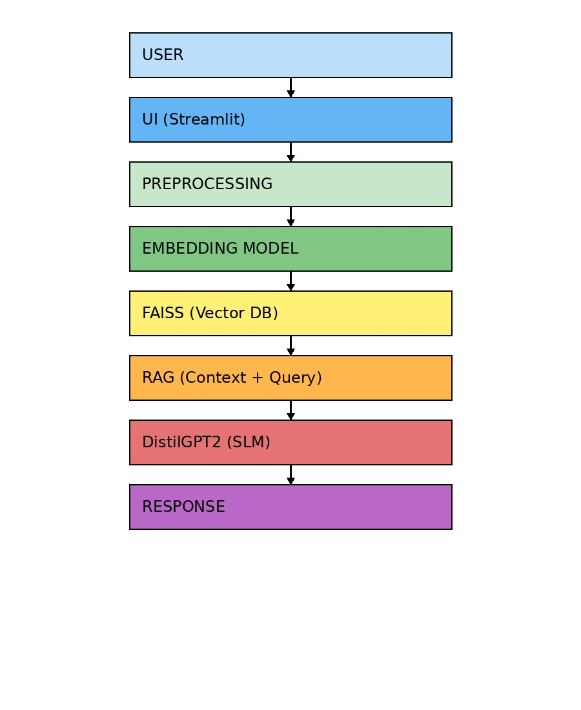

5.3 Experiment Tracking
Experiment tracking is a crucial component of the MLOps pipeline that helps in recording and managing different experiments conducted during model development. In this project, experiment tracking was performed to monitor parameters, model configurations, and performance metrics during the development of the chatbot.
We tracked key parameters such as model name (DistilGPT2), maximum token length, and preprocessing techniques used. Performance metrics such as response time, relevance, and accuracy of generated answers were observed and compared across different test queries. This helped in identifying the most efficient configuration for the chatbot system.
Due to the lightweight nature of the project, basic experiment tracking was implemented using Python logging and manual recording instead of advanced tools like MLflow or Weights & Biases. Logs were maintained to track model behavior and response quality for different inputs.
Experiment tracking played a significant role in improving the system by enabling comparison between different configurations and ensuring reproducibility. It also helped in selecting the final model setup that provided the best balance between performance and efficiency.

6. Modules Identified
The project is organized into the following functional modules, each responsible for a distinct aspect of the MLOps lifecycle:

Module | Responsibility | Key Components
Data Module | Handles all data-related operations | Ingestion, cleaning, versioning, splitting
Model Module | Manages model definition and training | Architecture, training loop, fine-tuning
Evaluation Module | Measures model quality | Metrics computation, test harness, reporting
Serving Module | Exposes the model for inference | REST API, UI, request/response handling
Monitoring Module | Tracks production health | Latency, drift detection, alerts
[STUDENT: Add custom modules] | [Description] | [Components]

Data Module
The Data Module is responsible for handling all data-related operations, including dataset ingestion, cleaning, preprocessing, and preparation. The university chatbot dataset is loaded from a CSV file and processed using libraries such as pandas. Preprocessing steps include removing duplicates, handling missing values, and normalizing text through tokenization and lowercasing. This module ensures high-quality and structured input data, which is essential for accurate retrieval and response generation. The processed data is then passed to the embedding module for vector representation.
Model Module
The Model Module manages the loading and execution of the small language model used in the system. In this project, the DistilGPT2 model is loaded using the Hugging Face Transformers library along with its tokenizer. The module is responsible for performing inference by generating responses based on the input query and retrieved context. Since the model is lightweight, it enables efficient local execution without requiring high computational resources. This module integrates with the retrieval component (RAG) to produce context-aware responses.
Evaluation Module
The Evaluation Module is used to assess the performance and quality of the chatbot system. It evaluates responses based on criteria such as relevance, accuracy, and response time. Basic evaluation techniques include comparing generated responses with expected answers and analyzing user feedback. Metrics such as response latency and correctness are considered to ensure system reliability. This module helps in identifying areas for improvement and optimizing model performance.
Serving Module
The Serving Module is responsible for deploying the chatbot and enabling user interaction. In this project, Streamlit is used to build a simple and interactive web-based user interface. The module accepts user queries, sends them through the processing pipeline, and displays generated responses in real time. It acts as the bridge between the user and the backend system components. This module ensures smooth communication and usability of the chatbot application.
Monitoring Module
The Monitoring Module tracks the performance and health of the chatbot system during operation. It monitors key metrics such as response time, system latency, and usage patterns. Logging mechanisms are implemented to record user queries and system outputs for analysis. This module helps in detecting issues such as slow responses or incorrect outputs. Continuous monitoring ensures system reliability and supports future improvements.

8. Conclusion
Our project addressed the limitation of general chatbots in providing accurate, location-specific information by developing a Local Knowledge Chatbot using an LLM integrated with a curated dataset. A Retrieval-Augmented Generation approach and a complete end-to-end MLOps pipeline were implemented for efficient data processing, deployment, and monitoring. The results showed improved accuracy, relevance, and faster response compared to traditional systems. Overall, the project successfully met its objectives by delivering a scalable and practical solution for localized information retrieval.
This project demonstrated a complete MLOps workflow — from raw data to a deployed, monitored model. The integration of experiment tracking, version control, and automated pipelines highlighted the practical importance of MLOps principles in real-world AI development.
Furthermore, this project highlights the effectiveness of combining small language models with retrieval-based techniques to build efficient and domain-specific chatbot systems. By leveraging local deployment and optimized processing, the solution ensures data privacy, reduced dependency on external services, and faster response times. The implementation demonstrates that even lightweight models, when integrated with proper MLOps practices, can deliver reliable and scalable real-world applications.

Appendix

A. Declaration
We, the undersigned, declare that this MLOps project report is the result of our own original work carried out under the guidance of our faculty. The similarity score of this report is less than 20% as verified by the plagiarism detection tool.

Name | SRN | Signature | Date
Thanuja | R23EA081
Seema | R23EA111
Geethika | R23EA069
Varshini | R23EA068

B. Code Repository
GitHub / Repository Link | https://github.com/Seemakamble7829/local-knowledge-chatbot
Branch | main
README Available? | Yes

C. Tools and Technologies Summary
Category | Tool / Technology | Version
Language | Python | 3.10+
LLM Framework | Hugging Face Transformers] | Latest
Experiment Tracking | Basic Logging (Python) | Latest
Data Processing | pandas, NumPy | Latest
Deployment | Streamlit | Latest
Version Control | Git + GitHub | Latest
Vector Database | FAISS | Latest

